**[Karitejevo maslo](http://www.ognjic-logatec.si/naravna-kozmetika/karitejevo-maslo)**

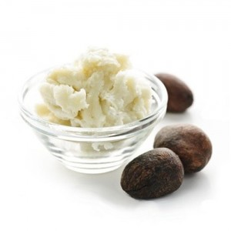

[http://www.weebly.com/weebly/images/file_icons/pdf.png](http://www.ognjic-logatec.si/uploads/6/4/0/9/6409875/letak_črna_podlaga.pdf)

|  |  |  |
| --- | --- | --- |
|  | |  | | --- | | **Letak KARITE** |   [**Download File**](http://www.ognjic-logatec.si/uploads/6/4/0/9/6409875/letak_črna_podlaga.pdf) |